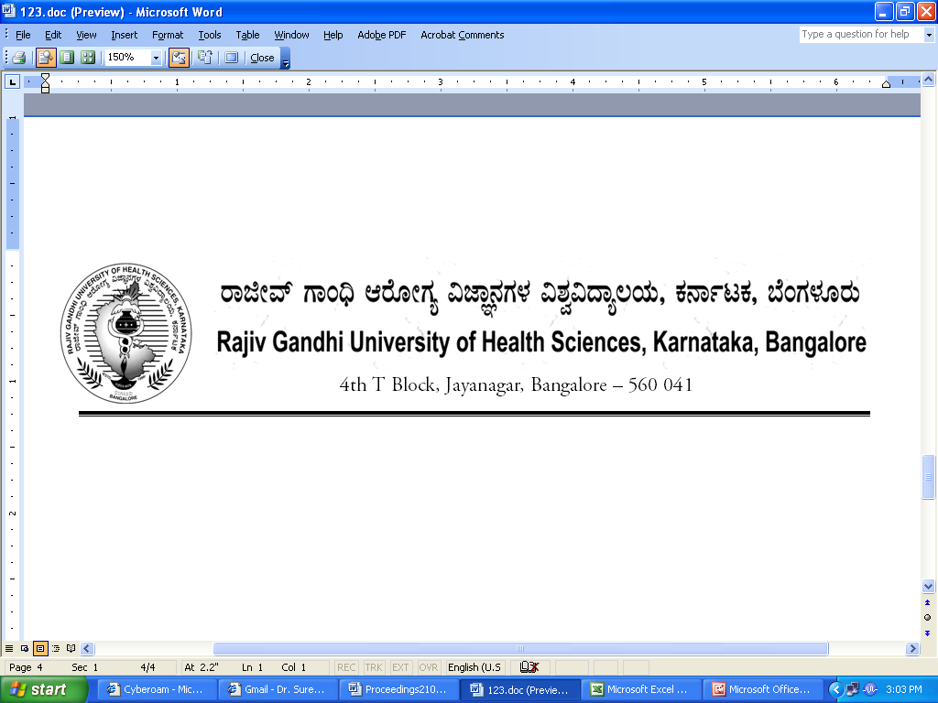
Reg(E)Exam/SPL/December- 2017 Date: 02/11/2017

To,

The Director / Dean / Principals of
All Super Specialty Colleges
Affiliated to RGUHS.

Sir / Madam,

Sub : | Providing the number of students appearing for Super Specialty course examination December- 2017.

With reference to the above, you are hereby requested to send the number of students appearing December-2017 Super Specialty examination same may be informed in the following proforma on or before 15/11/2017 through fax: 080-26961941 or email:drexamrguhs@gmail.com without fail to speed up the examination process.
Super Specialty

Name of the Student | Register No | Name of the Course

Thanking you,

Yours faithfully,

Sd/-
Registrar [Evaluation]

An ounce of action is worth a ton of theory

